## Migracion.2.SUI módulos. datos Hominis

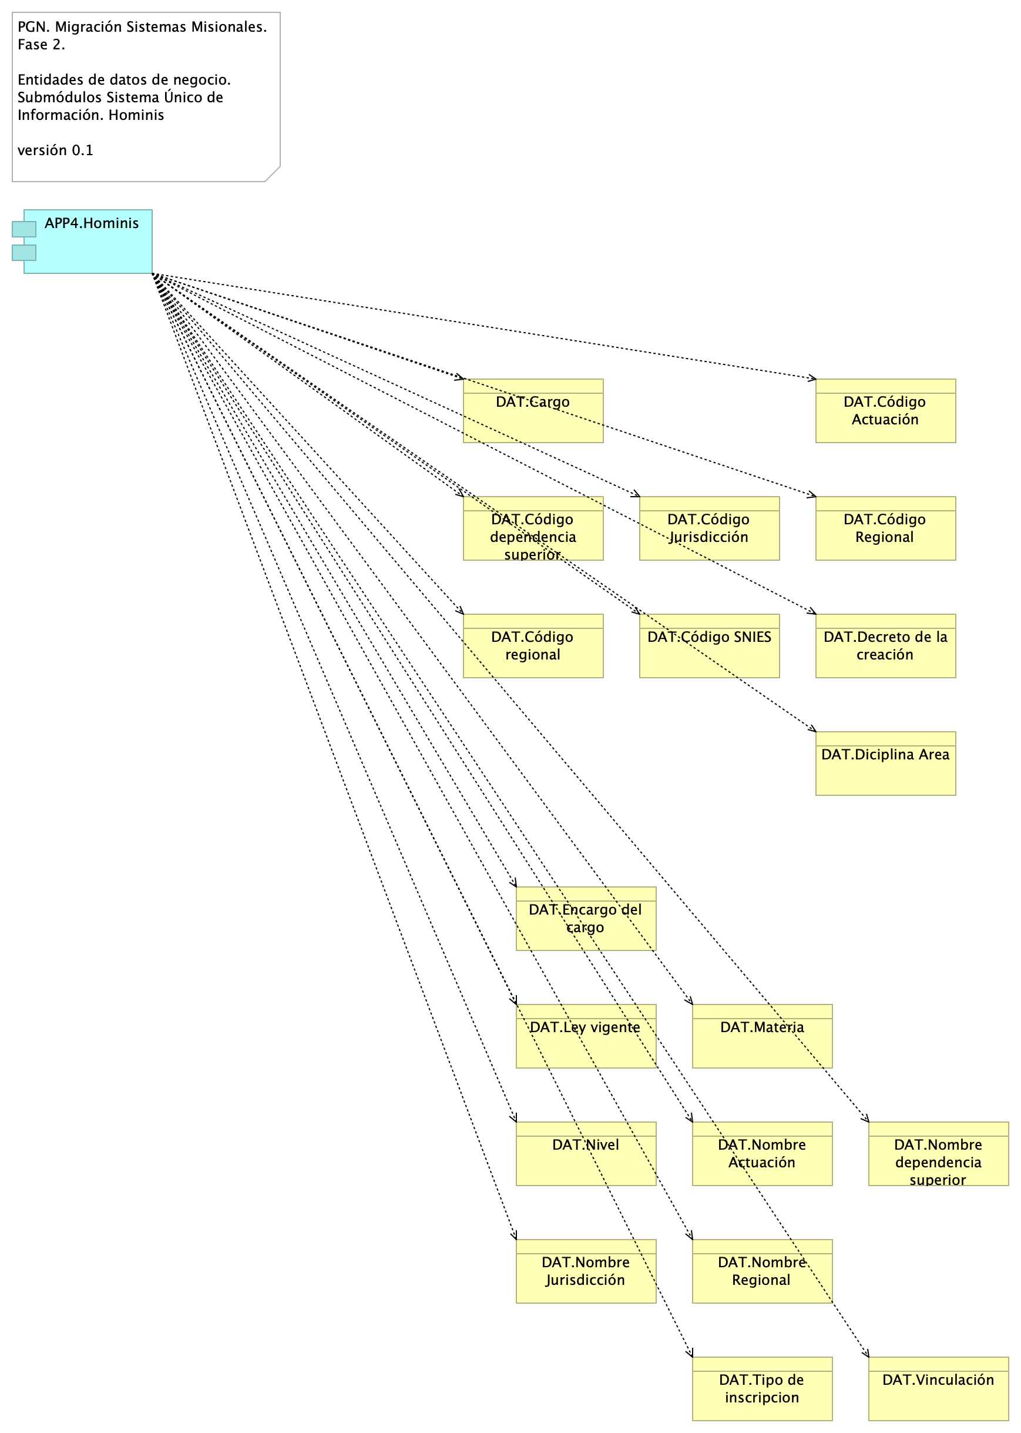

Figure 1: Diagram: Migracion.2.SUI módulos. datos Hominis

### Catálogo de Elementos

| Name | Type | Description | Properties |
| --- | --- | --- | --- |
| **APP4.Hominis** | application-component |  |  |
| **DAT.Cargo** | business-object |  |  |
| **DAT.Código Actuación** | business-object |  |  |
| **DAT.Código Jurisdicción** | business-object |  |  |
| **DAT.Código Regional** | business-object |  |  |
| **DAT.Código SNIES** | business-object |  |  |
| **DAT.Código dependencia superior** | business-object |  |  |
| **DAT.Código regional** | business-object |  |  |
| **DAT.Decreto de la creación** | business-object |  |  |
| **DAT.Diciplina Area** | business-object |  |  |
| **DAT.Encargo del cargo** | business-object |  |  |
| **DAT.Ley vigente** | business-object |  |  |
| **DAT.Materia** | business-object |  |  |
| **DAT.Nivel** | business-object |  |  |
| **DAT.Nombre Actuación** | business-object |  |  |
| **DAT.Nombre Jurisdicción** | business-object |  |  |
| **DAT.Nombre Regional** | business-object |  |  |
| **DAT.Nombre dependencia superior** | business-object |  |  |
| **DAT.Tipo de inscripcion** | business-object |  |  |
| **DAT.Vinculación** | business-object |  |  |